LDA Topic Modelling Report on the MyIWC Forum Dataset
A Comprehensive Analytical & Visual Summary

1. Dataset Overview
The MyIWC Forum Dataset, created by the University of Arizona’s Artificial Intelligence Lab, contains English-language forum discussions collected between November 2000 and February 2010.
Dataset Summary
- 📝 Total Posts: 25,016
- 🧵 Threads: 6,310
- 👥 Members: 756
- 🌐 Language: English
- 📄 Format: Plain text (unzipped ~53 MB)
- 📥 Loaded into Notebook: 24,870 documents
This dataset primarily includes personal religious reflections, interfaith debates, theological discussions, Middle Eastern political threads, humanitarian topics, and general forum help/resources.

2. Workflow Overview
The analysis consists of the following major phases:
- Library & Environment Setup
- Dataset Loading
- Text Preprocessing (spaCy-based)
- Dictionary & Corpus Creation (Gensim)
- LDA Topic Modeling (10 topics)
- Document Categorization
- Visualization & Insights
Workflow Summary:
Dataset → Cleaning → Tokenization → Lemmatization → Dictionary → Corpus → LDA Model → Topic Assignment → Visualization

3. Detailed Preprocessing Pipeline
The preprocessing pipeline ensures clean, meaningful tokens suitable for LDA topic modeling. Below is a structured and clear explanation of each transformation.
Step-by-Step Text Preprocessing
📌 1. Convert to String
All documents are converted to string format to avoid errors caused by numeric or mixed data types.
📌 2. Remove URLs
All web links (http, https, www) are removed to prevent noisy tokens.
📌 3. Remove Non-English Characters
A corrective filter removes anything except English letters and spaces, eliminating:
- Arabic text
- Numbers
- Emojis
- Punctuation
- Special characters
This step dramatically improves text clarity.
📌 4. Tokenization with spaCy
spaCy splits each sentence into tokens with linguistic properties.
📌 5. Stopword Removal
Common words (the, and, is, etc.) are removed because they do not contribute to topic meaning.
📌 6. Alphabetic Filtering
Only pure alphabetic tokens are retained.
📌 7. Lemmatization
Words are reduced to their root forms:
- “women” → woman
- “thinking” → think
- “Christians” → christian
This reduces vocabulary noise and boosts topic coherence.
📌 8. Minimum Length Filtering
Tokens shorter than 3 characters are removed.

✨ Output of Preprocessing
Each document becomes a clean list of meaningful lemmas.
Example:
Before:
“I am not sure either but I think there is a hadith… http://example.com”
After:
["sure", "think", "hadith"]

4. Building Dictionary & Corpus
✔ Dictionary
Maps each unique lemma to an ID.
✔ Filtering
- Words appearing in fewer than 5 documents removed
- Words appearing in more than 50% of documents removed
✔ Corpus
Each document is converted into a Bag-of-Words vector of (word_id, frequency) pairs—the required input for LDA.

5. LDA Topic Model Training
The Latent Dirichlet Allocation (LDA) model was trained with:
- 10 topics
- 10 passes over the corpus
- Random seed = 100
- Gensim’s LdaModel implementation
The model outputs topic-word distributions and document-topic probabilities.

6. LDA Topics with Custom Labels
Your custom topic labels improve interpretability. The table below summarizes the topics:
🟦 LDA Topic Table (with Weights & Labels)
Topic | Label | Top Keywords & Weights
0 | Social Life & Family Discussion | quot (0.060), woman (0.024), man (0.021), child (0.014), tell (0.009)…
1 | Middle East Conflict (Iraq/Israel/Palestine) | israel (0.014), war (0.013), iraq (0.007), attack (0.007)…
2 | Comparative Religion (Islam/Christianity) | jesus (0.027), god (0.025), bible (0.015), qur (0.013)…
3 | Theology & Creation | god (0.060), earth (0.014), life (0.013), spirit (0.009)…
4 | Website/Forum Help & Resources | site (0.014), amp (0.012), read (0.011), help (0.008)…
5 | Hadith & Prophet’s Teachings | prophet (0.027), ibn (0.017), allaah (0.016), hadith (0.009)…
6 | General Discussion on Islam & Muslims | people (0.013), muslim (0.013), world (0.011), islamic (0.008)…
7 | Geopolitics & Health/Humanitarian Issues | taliban (0.016), pakistan (0.015), afghanistan (0.014), food (0.009)…
8 | Personal Opinions on Islam | islam (0.024), know (0.013), think (0.011), religion (0.010)…
9 | Faith & Spirituality (Allah, Love, Sin) | allah (0.070), good (0.010), love (0.007), heart (0.007)…

7. Categorization of All Documents
Each document was assigned the topic with the highest probability score.
Sample Output
Text (shortened) | Category | Confidence
“I think there is a hadith…” | Faith & Spirituality | 43.86%
“Virtues of Salaam…” | Hadith & Prophet’s Teachings | 59.36%
“Let's Shine Together…” | Theology & Creation | 40.39%
“[Edited forum post]…” | Social Life & Family Discussion | 48.71%

8. Topic Distribution (Visualization Added)
A horizontal bar chart illustrates how many documents fall under each topic.
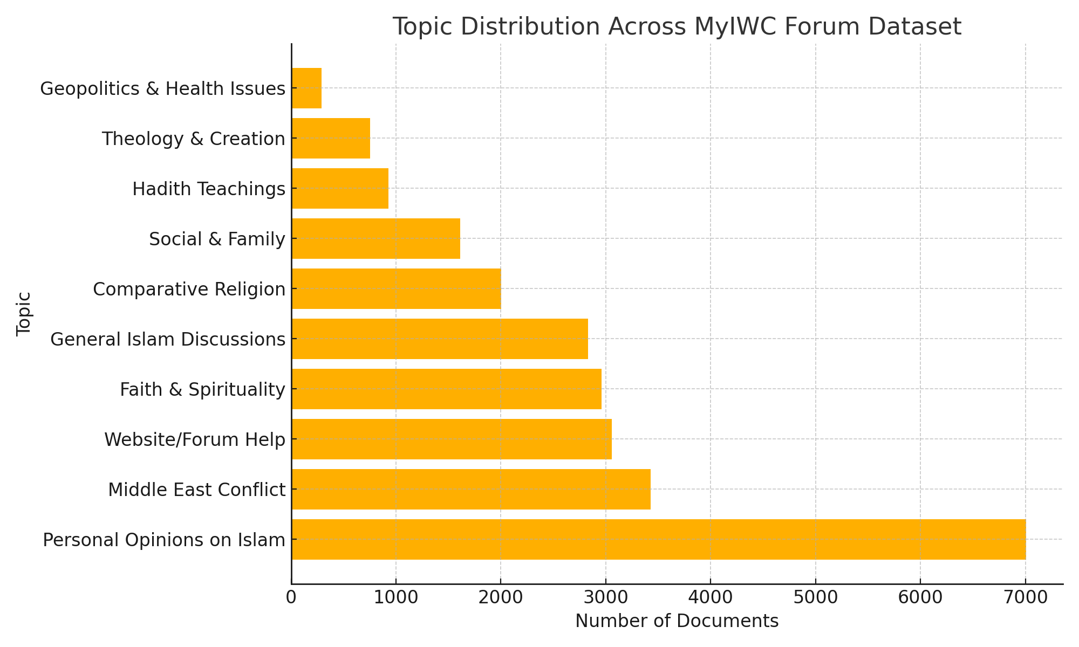

9. Visualization of Topics
To visually interpret topic relationships and keyword importance, multiple visualizations were generated.
9.1 pyLDAvis Interactive Topic Map
The pyLDAvis interface provides:
- Intertopic Distance Map (Left):
Each topic is displayed as a circle.
  - Circle size → topic prevalence
  - Distance → similarity/difference between topics
- Top Terms List (Right):
Shows the most relevant terms for a selected topic.
This helps identify dominant themes, overlapping clusters, and topic coherence.

Topic 1:
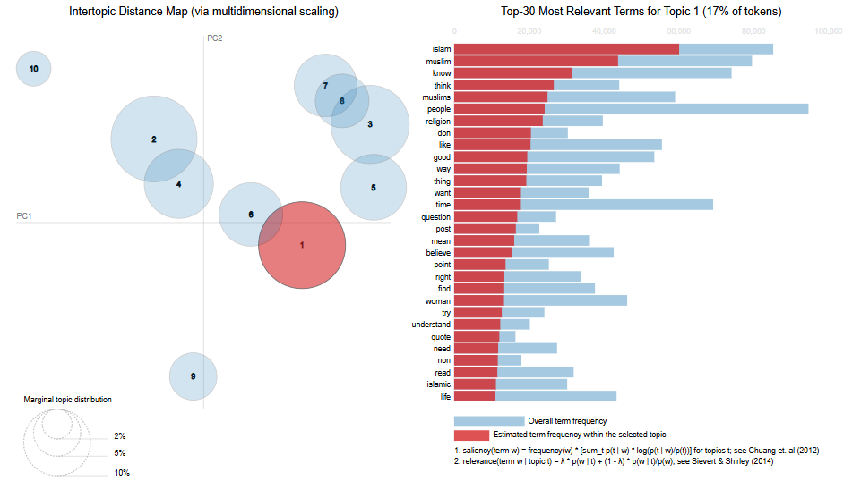

Topic 8:
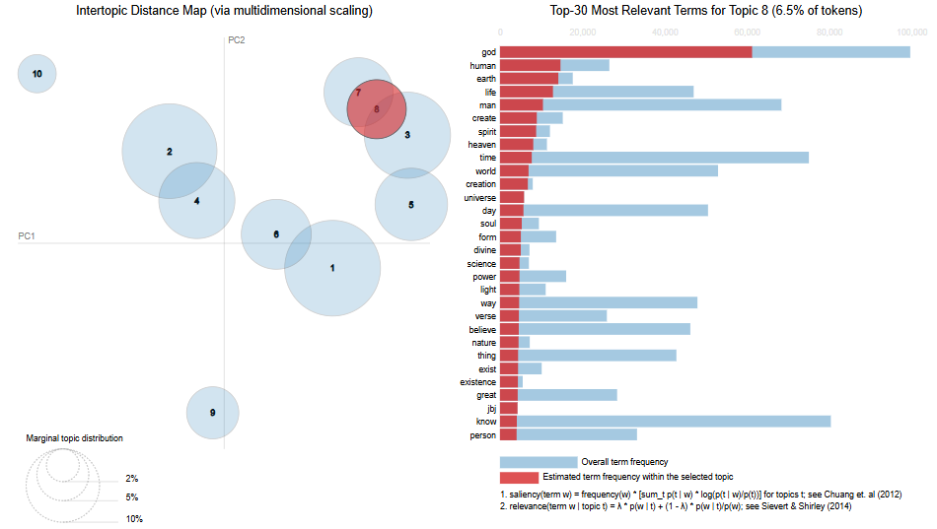
Topic 10:
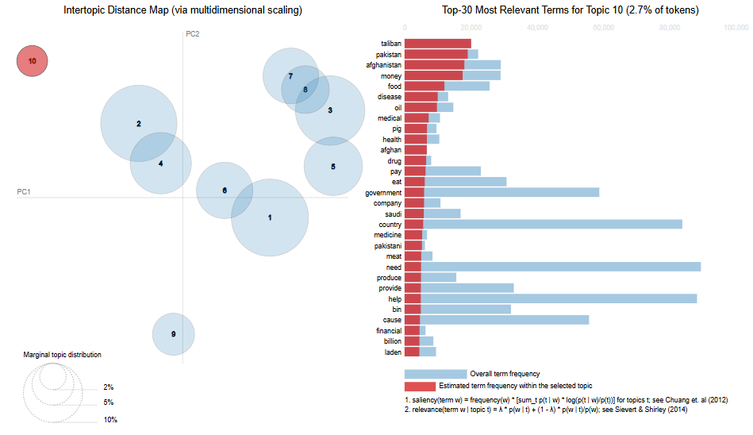

9.2 Topic Distribution Chart
A bar chart displays topic frequencies and highlights dominant themes.
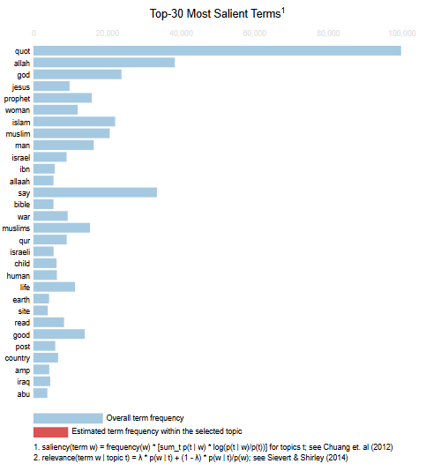
9.3 Topic Word Clouds
Word clouds were generated for all ten topics. Larger words represent higher weighting in the LDA model.
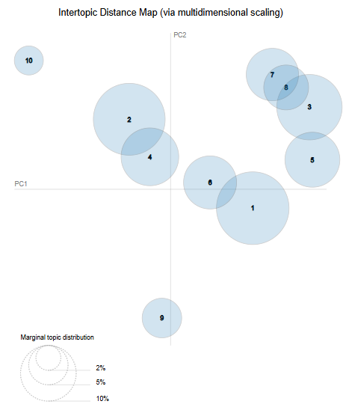

10. Key Insights
🔹 Highly Religious Forum
The largest categories involve personal Islamic reflections, belief discussions, and general Islamic topics.
🔹 Strong Interfaith Focus
Comparative religion (Christianity vs Islam) forms one of the largest thematic clusters.
🔹 Middle East Politics
Discussions on Israel, Palestine, Iraq, and Afghanistan appear frequently.
🔹 Community & Help-Oriented Content
A notable amount of content is centered on website help, shared resources, and personal life discussions.

11. Conclusion
This LDA-based analysis reveals that the MyIWC forum blends:
- Faith-centered discussions
- Hadeeth and prophetic teachings
- Interfaith debates
- Theological and philosophical content
- Political and humanitarian threads
- Personal reflections and community support
The preprocessing pipeline produced clean and meaningful input, and the topic visualizations clearly highlight thematic structures.
The 10-topic LDA model provides a well-organized understanding of the MyIWC forum’s content and dominant themes.

